Activity 0 -
Figure 1 - TrueNAS Storage
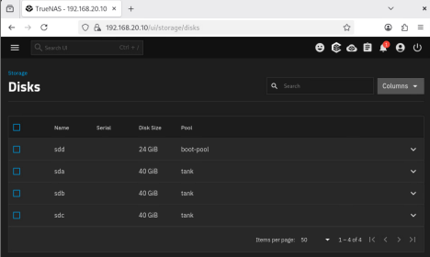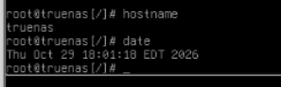
Activity 1 -
Figure 2 - Pool Topology and Datasets
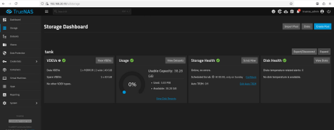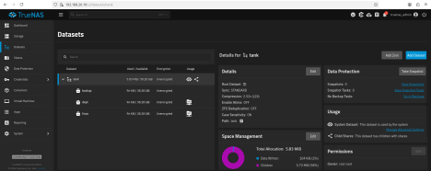
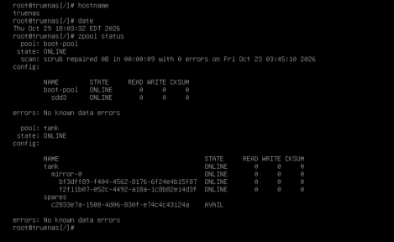Bookstack note:
I used a mirror instead of a RAIDZI because the lab only needed two data disks. The mirror would be able to keep a copy of data on both disks.
Figure 3 - Directory Services Healthy
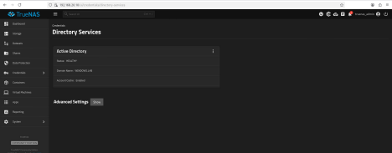Figure 4 - SMB Writer and Reader
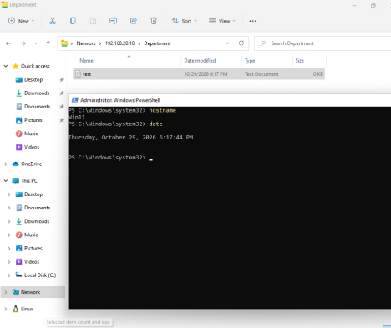
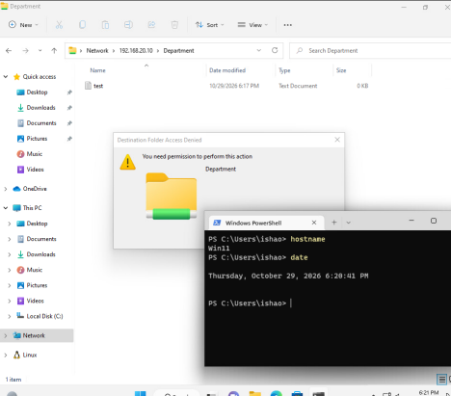Figure 5: NFS Client Mount
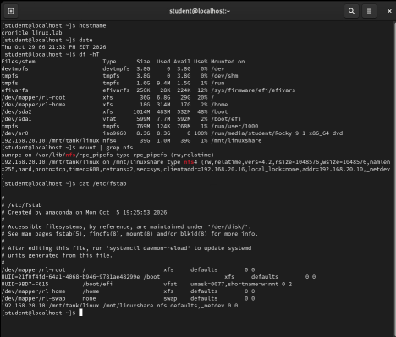
Activity 3:
Figure 6: 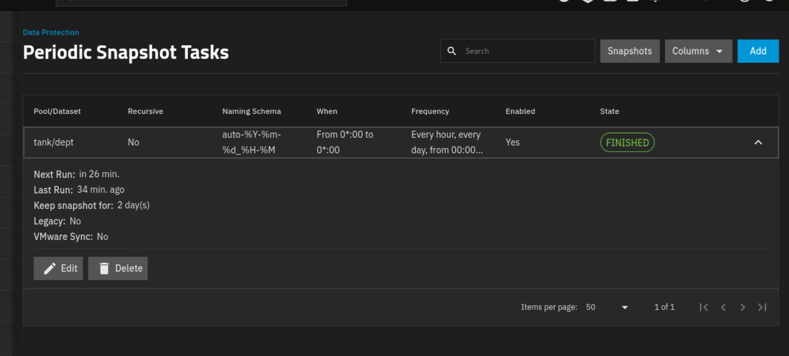
Figure 7:
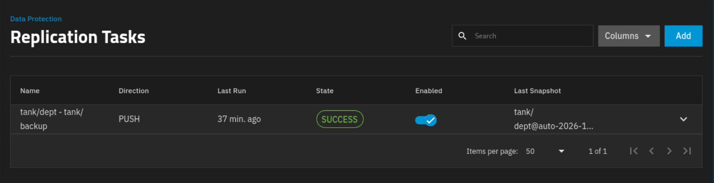
Figure 8:
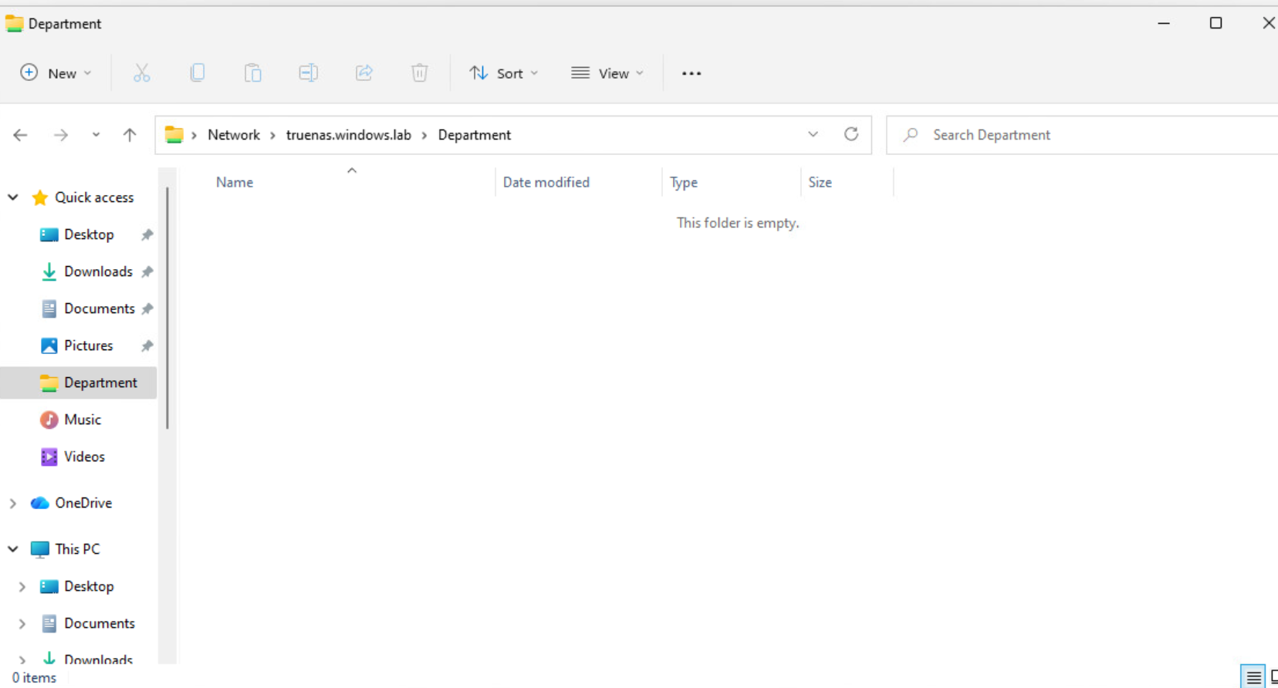
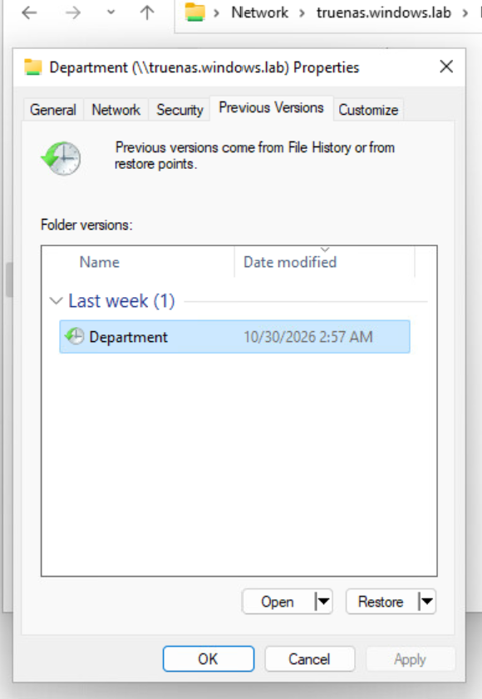
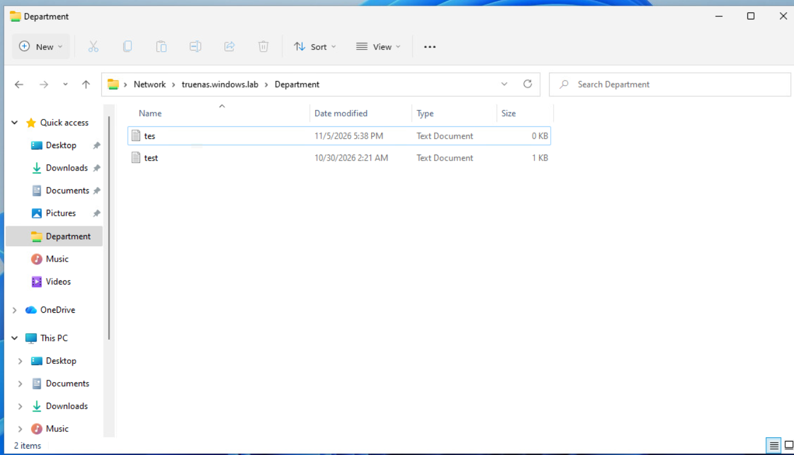
(taken during the lab showcase, so that explains the two files)
Figure 9


